Error Detection

Error

1. Data are transmitted in the network
2. The data can be corrupted during transmission
3. Transmission error
4. For reliable communication, errors must be detected and corrected
5. Error detection and correction are implemented either at the data link layer or the transport layer of the OSI model.
6. Type of error:
   1. Bit error:
      1. Aka single bit error
      2. Only 1 bit in the data unit has been changed.
      3. 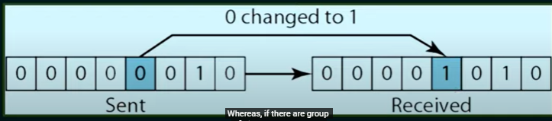
   2. Burst error:
      1. 2 or more bits in the data unit have changed.
      2. 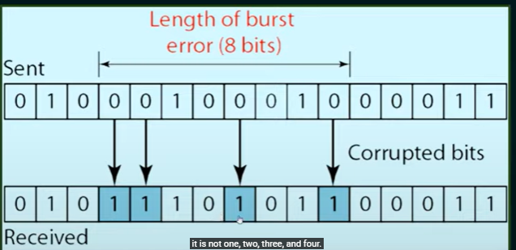

How to detect the errors?

1. Error detection means to decide whether the received data is correct or not without having a copy of the original message
2. To detect or correct errors, we need to send some extra bits with the data.
3. The extra bits are called redundant bits.
4. 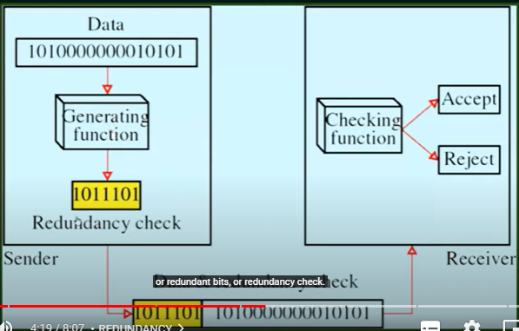

Error correction

Wo ways to do:

1. Receiver can have the sender retransmit the entire data unit
2. The receiver can use an error-correcting code, which automatically corrects certain errors.
3. 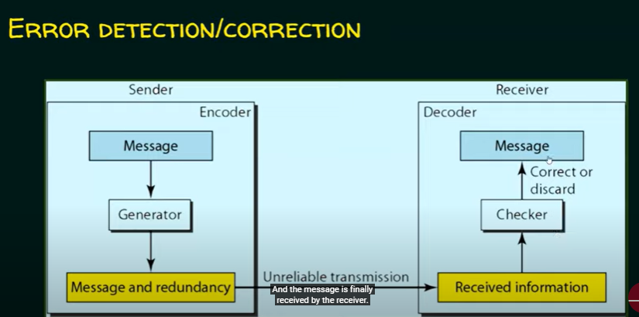

Error detection techniques:

Four types of redundancy checks are used in data communications:

1. Vertical Redundancy Check (VRC)
2. Longitudinal Redundancy Check (LRC)
3. Checksum
4. Cyclic Redundancy Check (CRC)